Include the title of the full paper here

Corresponding Author^{1*}, Presenting Author² and Author³
¹ Aﬃliation
² Aﬃliation
³ Aﬃliation
* Email address of the corresponding author

Abstract:
Inset your abstract here. Make sure that the abstract properly reflects your work and is limited to 200 words. The abstract should be the point-of-entry for the scientific paper.

Keywords: keyword 01, keyword 02, keyword 03, keyword 04 and keyword 05

- Section
Include section 01 here.
You can include subsections too.

  - Subsection
More subsections can be included.

  - Subsection

- Section

Label all the equations in your manuscript unless it is an exceptional case.

x² + y² + z² = 1 (1)

You may include figures, tables etc, they all should be captioned properly.
Also you can include tables.
Add references manually to the manuscript.

I | 7000
 | 6000
 | 5000
 | 4000
 | 3000
 | 2000
 | 1000
 | 0 | 1−Apr 15−Apr 1−May15−May 1−Jun 15−Jun | 1−Jul 15−Jul | 1−Aug15−Aug | 1−Sep15−Sep
 | 1−Feb15−Feb 1−Mar15−Mar
 |  | time (days)
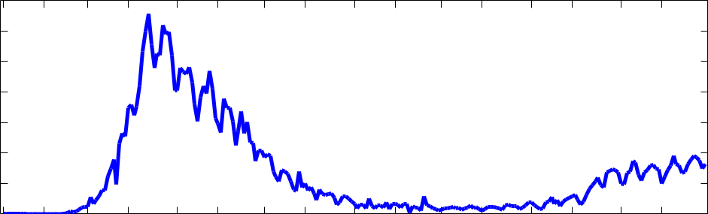
Figure 1: Insert the Figure caption here.

Table 1: Insert the Table caption here.
Heading 1 | Heading 2 | Heading 3
Item | Item | Item
Item | Item | Item
Item | Item | Item

References

- Boixo, S., Rønnow, T.F., Isakov, S.V., Wang, Z., Wecker, D., Lidar, D.A., Martinis, J.M. and Troyer, M., Evidence for Quantum Annealing with more than One Hundred Qubits, Nature Physics, 10(3), 218, 2014.

- Cairnie, N. and Edwards, K., Some Results on the Achromatic Number, Journal of Graph Theory, 26(3), 129–136, 1997.

- Calude, C.S. and Dinneen, M.J., Solving the Broadcast Time Problem us-ing a D-Wave Quantum Computer, Advances in Unconventional Computing, Springer, 439–453, 2017.

